**Automating Infrastructure using Terraform**

Course-end Project 1

**DESCRIPTION**

Use Terraform to provision infrastructure

**Description:**

Nowadays, infrastructure automation is critical. We tend to put the most emphasis on software development processes, but infrastructure deployment strategy is just as important. Infrastructure automation not only aids disaster recovery, but it also facilitates testing and development.

Your organization is adopting the DevOps methodology and in order to automate provisioning of infrastructure there's a need to setup a centralised server for Jenkins.

Terraform is a tool that allows you to provision various infrastructure components. Ansible is a platform for managing configurations and deploying applications. It means you'll use Terraform to build a virtual machine, for example, and then use Ansible to install the necessary applications on that machine.

Considering the Organizational requirement you are asked to automate the infrastructure using Terraform first and install other required automation tools in it.

**Tools required:** Terraform, AWS account with security credentials, Keypair

**Expected Deliverables:**

* Launch an EC2 instance using Terraform
* Connect to the instance
* Install Jenkins, Java and Python in the instance

**Launching an EC2 instance using Terraform**

**Creation of Terraform user on AWS-IAM**

Providing access and secret key on Terraform to connect to AWS

Creation of Key pair for secure connection on EC2 instance on AWS

**Key pair to connect to instance**

**Key pair created on .tf file**

**Creating my AWS resource on Terraform**

**Executing terraform init command**

**Executing terraform validate**

**Executing terraform apply to see what plan terraform has and create the resource**

**Executing terraform apply to see what plan terraform has and create the resource after yes response**

**Instance created via terraform running on AWS EC2**

**Instance created via terraform running on AWS EC2 showing key pair and security group**

**Connected to instance terminal**

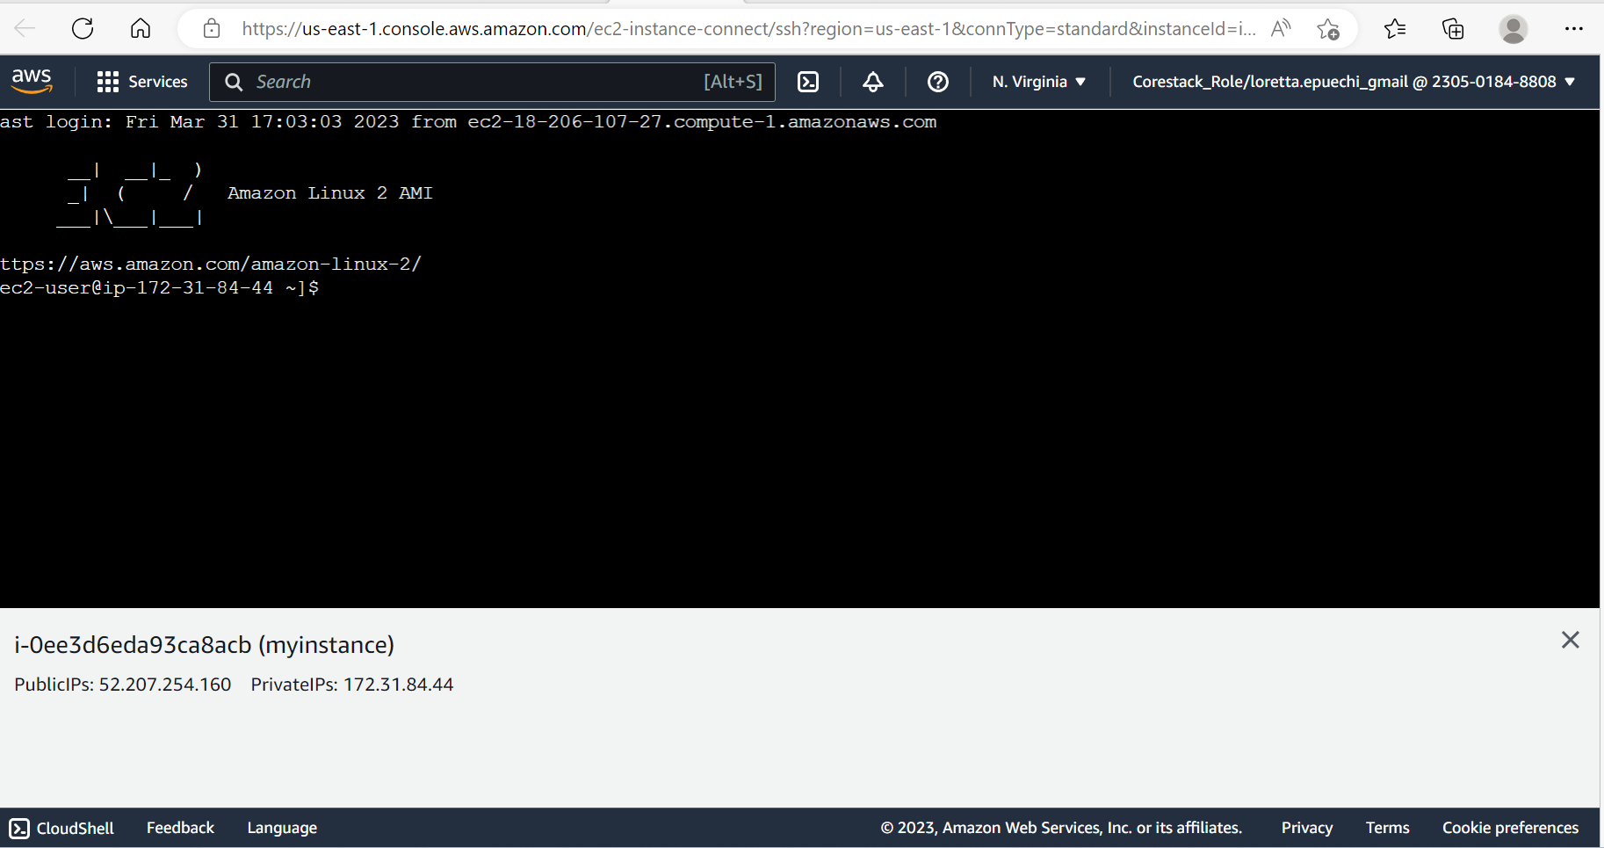

**Git version available and java installed on instance in AWS EC2**

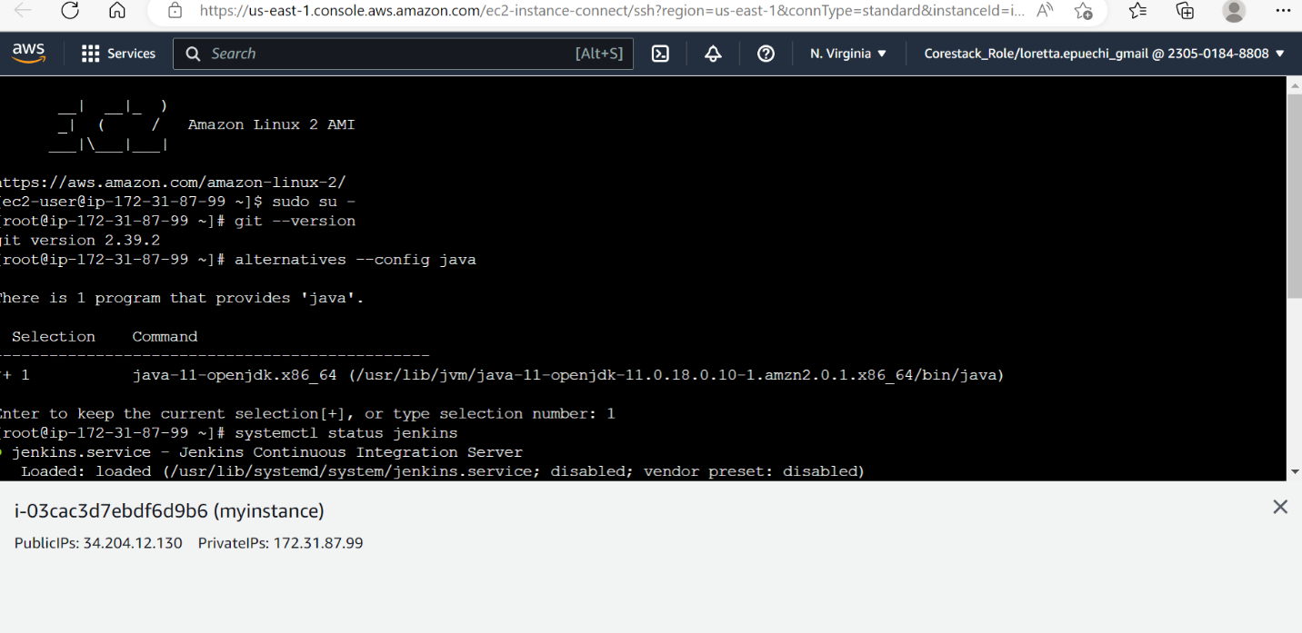

**Jenkins installed on instance in AWS EC2**

**Python version installed on instance in AWS EC2**

